Name:___________________________________________ Date: _______________________

Calculus: 5-5 HW Trapezoidal Rule VISCA

In Exercises 1–6,

**(a)** Use the Trapezoidal Rule with *n* = 4 to approximate the value of the integral.

**(b)** Use the concavity of the function to predict whether the approximation is an overestimate or an underestimate.

**(c)** Find the integral’s exact value to check your answer.

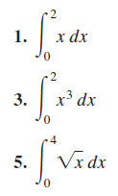



**7.** Use the function values in the following table and the Trapezoidal Rule with *n* = 6 to approximate



**10.** *Stocking a Fish Pond* As the fish and game warden of your township, you are responsible for stocking the town pond with fish before the fishing season. The average depth of the pond is 20 feet. Using a scaled map, you measure distances across the pond at 200-foot intervals, as shown in the diagram.

**(a)** Use the Trapezoidal Rule to estimate the volume of the pond.

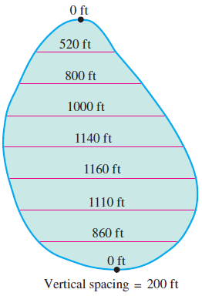**(b)** You plan to start the season with one fish per 1000 cubic feet. You intend to have at least 25% of the opening day’s fish population left at the end of the season. What is the maximum number of licenses the town can sell if the average seasonal catch is 20 fish per license?

In Exercises 13–18,

**(a**) use Simpson’s Rule with *n* _ 4 to approximate the value of the integral

**(b)** find the exact value of the integral to check your answer. (Note that these are the same integrals as Exercises 1–6, so you can also compare it with the Trapezoidal Rule approximation.)

